WeOD: A Lightweight DASH-Based VOD Codec Evaluation Platform

Cedar Huang
University of Illinois Urbana Champaign CS537 - Spring 2026

ABSTRACT
In this paper, we present WeOD, a lightweight DASH-based Video-on-Demand (VOD) experimental platform for codec and frame rate evaluation. Modern VOD systems are widely deployed across diverse environments and platforms, ranging from large-scale commercial streaming services to smaller private media platforms. At the same time, modern video delivery systems utilize a variety of streaming protocols and codec configurations, each with different tradeoffs in compression efficiency, playback performance, compatibility, and deployment complexity.
To investigate the performance tradeoffs among different codec and frame rate configurations, we develop a browser-based client-server VOD system that supports on-demand transcoding and DASH streaming. The system allows users to select codec and FPS configurations through a web interface while video content is stored and processed on the server side. During playback, the platform automatically collects frontend and backend performance metrics, including startup delay, transcoding time, and playback statistics, and stores them for further analysis.
Using this platform, we conduct preliminary experiments on multiple codec configurations under different playback settings. The collected results demonstrate the feasibility of lightweight automated evaluation for DASH-based streaming systems and provide insights into the tradeoffs between codec efficiency and playback performance.
CCS CONCEPTS
Networks → Network performance evaluation
Information systems → Multimedia streaming
KEYWORDS
DASH, VOD, Video Streaming, Codec Evaluation, H.264, H.265, VP9
1 Introduction
Video streaming and Video-on-Demand (VOD) systems have become widely deployed across modern Internet platforms, from large-scale commercial services such as YouTube and NicoNico, to smaller self-hosted media platforms and personal websites. The economic and network impact of online video streaming continues to grow rapidly. According to Alphabet’s investor reports, YouTube advertising revenue alone reached $9.9 billion in 2025, representing an 11% year-over-year growth [1]. In addition, Sandvine’s Global Internet Phenomena Report 2024 reports that on-demand streaming video generates the largest proportion of downstream Internet traffic among content categories, accounting for approximately 54% of total downstream volume [2]. Among these services, YouTube and Netflix contribute the highest per-subscriber traffic volume.
At the same time, the deployment environments of modern VOD systems have become more diverse and complex. Browser-based streaming systems are expected to support a wide range of browsers, operating systems, devices, and network conditions. According to StatCounter Global Stats, Google Chrome maintained approximately 65% global browser market share during 2025–2026, while Safari occupied roughly 15% of the market [3] Besides these two, browsers such as Microsoft Edge, Firefox, Samsung Internet, and Opera also maintain noticeable user bases. So, compatibility and playback behavior across various client environments have become important requirements for modern VOD systems.
Beyond platform diversity, video content itself may also shows significant different characteristics and performance requirements. Different streaming scenarios may emphasize different performance metrics, including startup delay, bandwidth consumption, transcoding speed, storage cost, or compatibility. Server hardware capability, storage capacity, and network conditions may also vary substantially across deployment environments. These factors collectively make the design and evaluation of VOD systems increasingly complex, particularly for lightweight or small-scale deployments.
Meanwhile, Several different video codecs have been came up and adopted in browser-based streaming systems, including H.264 and H.265. Different codecs have different tradeoffs in compression efficiency, computational complexity, browser compatibility, and transcoding performance. Consequently, different browser and transcoding tool support makes it difficult to systematically evaluate codec configurations.
To address these challenges and provide a more practical evaluation environment for codec comparison, we develop WeOD, a lightweight DASH-based VOD experimental platform for browser-based streaming evaluation. The system adopts a conventional client-server architecture and integrates dash.js in the frontend for browser-based video playback. A VOD server can be deployed on a Windows-based machine, while client devices may access and play selected video content through a web browser interface.
Before playback, users may configure codec and frame rate settings for the streaming session. During playback, frontend and backend performance metrics are automatically collected and stored on the server side for further analysis. Using this platform, different codec configurations can be evaluated under controlled experimental conditions, allowing more systematic analysis of codec behavior, playback performance, and compatibility characteristics across different streaming environments.
Theorem/Proof/Lemma. Insert text here for the enunciation or Math statement. Insert text here for the enunciation or Math statement. Insert text here for the enunciation or Math statement. Insert text here for the enunciation or Math statement. Insert text here for the enunciation or Math statement.
....Insert text here for the Quotation or Extract, Insert text here for the Quotation or Extract, Insert text here for the Quotation or Extract, Insert text here for the Quotation or Extract, Insert text here for the Quotation or Extract, Insert text here for the Quotation or Extract.
2 Background
2.1 DASH based streaming
Dynamic Adaptive Streaming over HTTP (DASH) is a standard HTTP-based streaming technique for transmitting multimedia content over the Internet. Instead of transmitting a video as a single continuous file, DASH divides and packs the media content into multiple short segments and describes the available media representations through a file, which is called Media Presentation Description (MPD). A DASH client receives the MPD first and then requests the corresponding media segments described in the MPD file through standard HTTP requests.
One important advantage of DASH is that it can operate through the existed HTTP infrastructure. Since DASH content is delivered through ordinary HTTP protocol, it can be deployed on any common web devices and could also benefit from existing network infrastructure. In this project, DASH is used for a lightweight local VOD system, where the server generates DASH segments and an MPD file for selected video content, and the browser client retrieves these resources directly from the Flask server.
In production systems, DASH is often used together with adaptive bitrate streaming, where the server would generate multiple representations of the same video with different bitrates or resolutions and the client dynamically selects among them according to network conditions. In contrast, WeOD focuses on controlled codec and frame rate evaluation rather than adaptive bitrate selection. Each experiment uses a selected codec and FPS configuration, and the generated DASH files will be used to support and measure playback behavior under the selected configuration.
2.2 Browser-Based Streaming Architecture
Browser-based video streaming systems usually adopted a server-client mode: it has a separate server-side media process, storage and delivery and client-side receive playback. The server processes the video file and provides media manifests and video segments through HTTP, while the client runs inside a web browser and is responsible for requesting media data, buffering, decoding, rendering, and user interaction.
For DASH-based playback, it is not enough to just include the video with a <video> tag. People usually build in a player analyze the MPD file, manage the buffer, request media segments, and manage playback through the browser media pipeline. This architecture allows DASH streaming to operate inside a standard web browser and take advantage of existing browser media capabilities. In WeOD, we integrated a widely used, open-source DASH player, dash.js.
DASH.JS. dash.js is an open-source JavaScript implementation for MPEG-DASH playback in browser-based environments. It supports the Media Source Extensions (MSE) [6]. It is available on GitHub and serves as the frontend playback component in WeOD. Instead of directly playing a single video file, dash.js first loads the MPD file, parses the available media presentation information, and then requests the corresponding media segments through HTTP.
MSE is a browser API that enables JavaScript applications to create media streams dynamically and play them through standard HTML media elements <video> [7]. This allows dash.js to append segmented media data to the browser playback buffer and perform DASH-style playback without requiring a separate native video player.
Since dash.js depends on browser media capabilities, successful playback is also related to the relevant container format, codec, and MSE environment. This makes browser compatibility an important factor when choosing codec configurations in browser-based VOD systems.
2.3 Video Codec and Transcoding
A video codec is used to compress video data during encoding. It usually comes with a tradeoff between speed, file size, visual quality, computational cost, and playback compatibility. For browser-based streaming systems, different codec could have different performance on speed, size cost, computation cost and environment support. MDN’s web video codec guide lists several common web video codecs and discusses their advantages and disadvantages, browser compatibility and container support.[8]. Among them, we choose H.264/AVC, H.265/HEVC, and VP9 to analyze in WeOD.
H.264, This codec is also known as AVC or MPEG-4 Part 10, was standardized by ITU-T and ISO/IEC MPEG, with the first ITU-T H.264 recommendation published in 2003.[9] It is a motion-compensation-based codec and has become one of the most widely used formats for video distribution, including web video, video conferencing, broadcast media, and Blue-ray.
The main advantage of H.264 is compatibility. MDN describes AVC as broadly compatible in HTML video, with support across major browsers and many platforms providing hardware encoding or decoding support. [8]
H.265, h.265 is also known as HEVC, was standardized as ITU-T H.265 and ISO/IEC 23008-2 in 2013.[10] It was designed as the successor to H.264, targeting higher compression efficiency and support for high-resolution video, including very high resolutions such as 4K and 8K. MDN notes that HEVC can theoretically achieve roughly half the compressed file size of AVC while maintaining comparable image quality.
However, H.265 is more complicated in a browser-based project because its support is less uniform than H.264. Browser playback often depends on the operating system, hardware decoder availability, and installed codec extensions. [8]
VP9 is an open and royalty-free video codec developed by the WebM Project, which is backed by Google. It became available in 2013 as the successor to VP8. VP9 was designed for web and mobile video use cases and is commonly associated with WebM and browser-based video delivery. [11]
Compared with H.264, VP9 generally targets better compression efficiency, and MDN describes its quality as comparable to HEVC at similar bitrates. VP9 is also widely supported in modern browsers, makes it a strong candidate for browser-based streaming experiments.[8]
2.4 Related works
Video codec comparison has always been a popular topic. Several papers have conducted related studies. In the following part we will introduce some related studies.
Laude et al. conducted a comprehensive comparison of modern video codecs, including AVC, HEVC, AV1, JEM, and VVC. Their study evaluates codecs under controlled configurations such as All Intra coding and Maximum Coding Efficiency. The results show that newer codecs can achieve higher coding efficiency than older standards, while also introducing higher computational complexity. However, their focus is mainly on codec-level rate-distortion performance rather than browser-based streaming behavior.[12]
Sharma et al. compared H.265/HEVC against H.264 and VP9 using FFmpeg. Their study analyzes these codecs in terms of space complexity, time complexity, compression size, bandwidth, efficiency, and practicality. This work is closely related to WeOD because it studies the same three codec families used in our project. However, their evaluation is mainly based on offline encoded outputs and compression-related measurements, while WeOD extends the comparison to an end-to-end web streaming workflow.[13]
De Cock et al. presented a large-scale comparison of x264, x265, and libvpx for practical video-on-demand applications. Their work evaluates open-source encoder implementations using objective quality metrics such as PSNR, SSIM, MS-SSIM, VIF, VMAF, and BD-rate. Compared with this large-scale VOD-oriented encoding study, WeOD has a smaller dataset and narrower experimental scope, but focuses on the practical behavior of codecs inside a lightweight browser-based DASH system.[14]
As we shown above, previous works extensively compared video codec under different constrains, compression efficiency, rate-distortion performance, encoding complexity, or large-scale VOD encoding quality.
In contrast, WeOD focuses on a practical lightweight, easy to deployed, browser-based DASH software, where videos are transcoded, segmented, and played through dash.js, and the measured metrics include startup delay, encoding time, slicing time, and playback-side behavior. By developing this software, we aim to explore the practical process of a VOD system and build a reuseable software for possible further analysis.
3 Design of the System
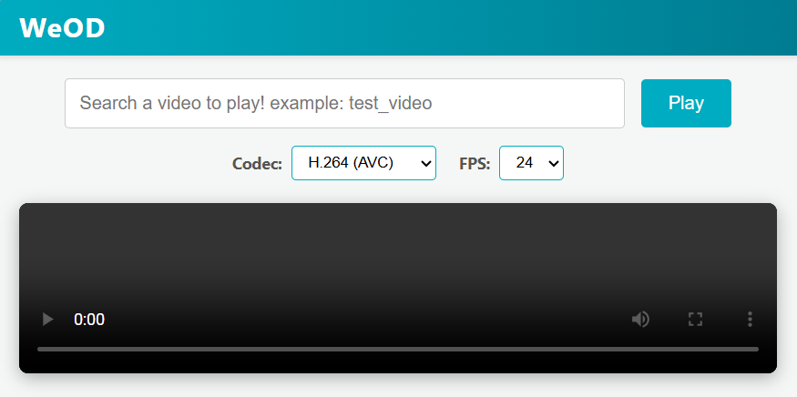
Figure 1: The web page and UI of the software
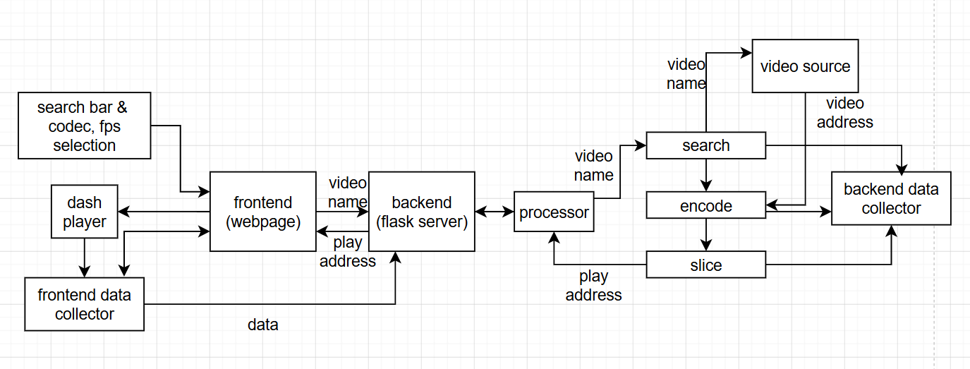
Figure 2: WeOD Software structure
4 Validation
4.1 Experiment Setup
The experiments are conducted on two different computers under a same LAN (Local area network). One work as the server, and the other one work as the client. The server computer takes responsibility to store the source videos,
4.2 Dataset
4.3 Evaluation Result
5 Conclusion
- In a Word 2010 document, insert a picture.
- Right click on the inserted picture and select the Format Picture option.
- Select the Alt Txt option from the left-side panel options.
- In the "Title:" and "Description:" text boxes, type the text you want to represent the picture, and then click "Close".
Below are steps to place alt-txt value in MS Word 2013/2016. To add alternative text to a picture in Word 2013/2016, follow these steps:
- In a Word 2013/2016 document, insert a picture.
- Right click on the inserted picture and select the Format Picture option.
- In the settings at the right side of the window, click on the "Layout & Properties" icon (3rd option).
- Expand Alt Txt option.
- In the "Title:" and "Description:" text boxes, type the text you want to represent the picture, and then click "Close".
1.1.1 Heading Level 3. Insert paragraph text here. Insert paragraph text here. Insert paragraph text here. Insert paragraph text here. Insert paragraph text here. Insert paragraph text here. Insert paragraph text here. Insert paragraph text here. Insert paragraph text here. Insert paragraph text here. Insert paragraph text here.
1.1.1.1 Heading Level 4. Insert paragraph text here. Insert paragraph text here. Insert paragraph text here. Insert paragraph text here. Insert paragraph text here. Insert paragraph text here. Insert paragraph text here. Insert paragraph text here. Insert paragraph text here. Insert paragraph text here. Insert paragraph text here.
ACKNOWLEDGMENTS
Insert paragraph text here. Insert paragraph text here. Insert paragraph text here. Insert paragraph text here. Insert paragraph text here. Insert paragraph text here. Insert paragraph text here. Insert paragraph text here. Insert paragraph text here. Insert paragraph text here. Insert paragraph text here.
REFERENCES
[1] Alphabet Inc. 2025. Alphabet Investor Relations. Retrieved May 12, 2026 from https://abc.xyz/investor/
[2] Sandvine. 2024. The Global Internet Phenomena Report 2024. Industry Report. Retrieved May 12, 2026 from https://www.sandvine.com/global-internet-phenomena-report
[3] StatCounter Global Stats. 2026. Browser Market Share Worldwide. Retrieved May 12, 2026 from https://gs.statcounter.com/
[4] MPEG. 2022. MPEG-DASH. Retrieved May 12, 2026 from https://www.mpeg.org/standards/MPEG-DASH/
[5] ISO. 2022. ISO/IEC 23009-1:2022 Dynamic adaptive streaming over HTTP (DASH) — Part 1: Media presentation description and segment formats. Retrieved May 12, 2026 from https://www.iso.org/standard/83314.html
[6] DASH Industry Forum. 2026. dash.js Documentation. Retrieved May 12, 2026 from https://cdn.dashjs.org/latest/jsdoc/index.html
[7] Mozilla Developer Network. 2026. Media Source API. Retrieved May 12, 2026 from https://developer.mozilla.org/en-US/docs/Web/API/Media_Source_Extensions_API
[8] MDN Web Docs. 2025. Web video codec guide. Mozilla Developer Network. Retrieved May 12, 2026 from https://developer.mozilla.org/en-US/docs/Web/Media/Guides/Formats/Video_codecs
[9] ITU-T. 2024. H.264: Advanced video coding for generic audiovisual services. International Telecommunication Union. Retrieved May 12, 2026 from https://www.itu.int/rec/t-rec-h.264
[10] ITU-T, "Parametric bitstream-based quality assessment of progressive download and adaptive audiovisual streaming services over HTTP," ITU-T Recommendation P.1203, Oct. 2017. [Online]. Available: https://www.itu.int/rec/T-REC-P.1203
[11] The WebM Project. n.d. VP9 Video Codec. Retrieved May 12, 2026 from https://www.webmproject.org/vp9/
[12] Laude T, Adhisantoso YG, Voges J, Munderloh M, Ostermann J. A Comprehensive Video Codec Comparison. APSIPA Transactions on Signal and Information Processing. 2019;8:e30. doi:10.1017/ATSIP.2019.23
[13] J. Sharma, T. Choudhury, S. C. Satapathy and A. S. Sabitha, "Study on H.265/HEVC against VP9 and H.264 : On Space and Time Complexity for Codecs," 2018 International Conference on Communication, Computing and Internet of Things (IC3IoT), Chennai, India, 2018, pp. 106-110, doi: 10.1109/IC3IoT.2018.8668132.
[14] Jan De Cock, Aditya Mavlankar, Anush Moorthy, and Anne Aaron "A large-scale video codec comparison of x264, x265 and libvpx for practical VOD applications", Proc. SPIE 9971, Applications of Digital Image Processing XXXIX, 997116 (27 September 2016); https://doi.org/10.1117/12.2238495

